The Baltimore Sun (Baltimore, Maryland) · Sun, Sep 10, 1961 · Page 51

https://[www.newspapers.com/image/377727755](http://www.newspapers.com/image/377727755) Downloaded on Feb 12, 2024

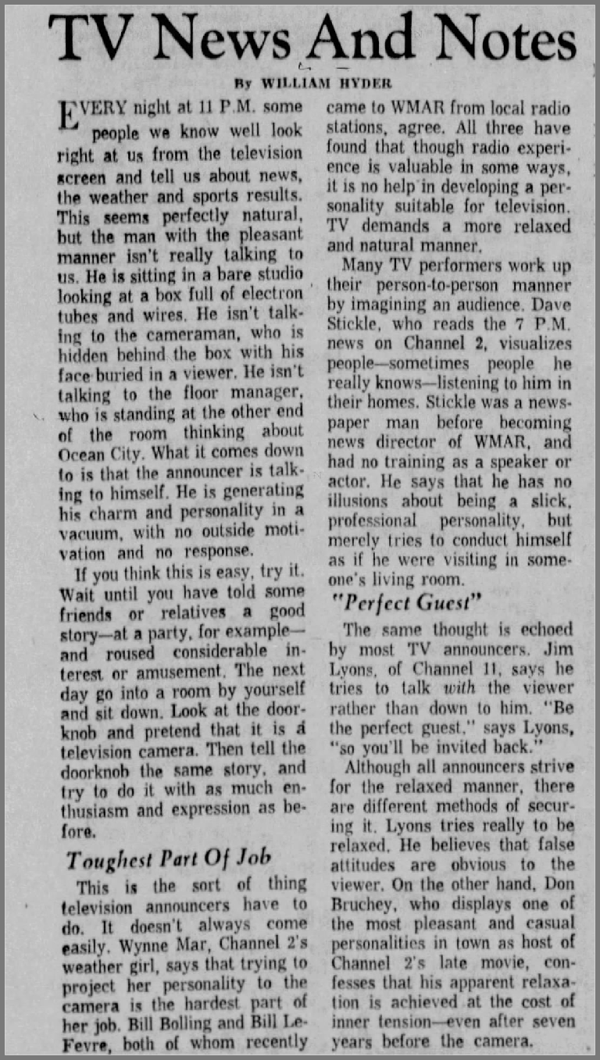

Copyright © 2024 Newspapers.com. All Rights Reserved.